Task 1.1
EXPLAIN at the start of the query just explains the plan of action, does not run the query.
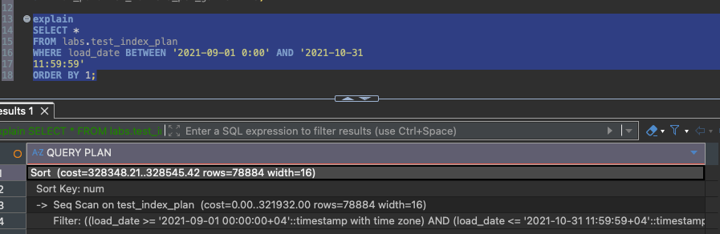
Explain Analyze actually runs the query.
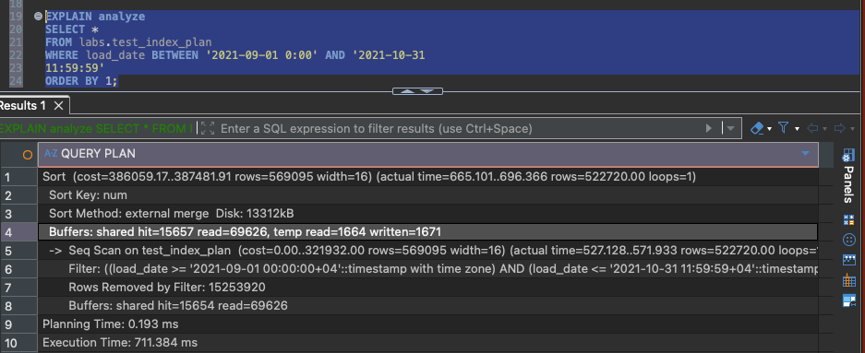
Using buffers ensures that it’s shown how much of memory/disk was used when executing the query, however as seen above with just EXPLAIN ANALYZE it was already shown in this case.
We’re not using any indexes so the process is Seq Scan.
The initial prediction if EXPLAIN was quite close – 78,884 rows predicted to be filtered in, however in reality it was 569,095. Rerunning just EXPLAIN now gives a much better approximate as the statistics have been updated after running the query.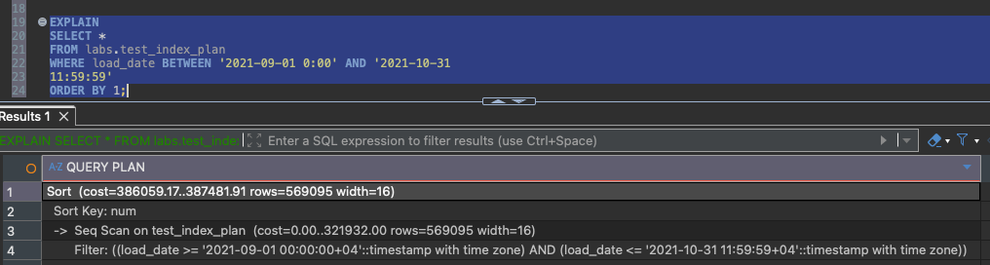

Task 1.2
With the B-Tree index created, the plan changed from Seq Scan to Index Scan. Instead of scanning the whole table, PostgreSQL jump to rows within the requested date range instead of checking all ~15 million rows.
The estimated number of rows (569,089) remains similar to before.
However, a Sort step is still required because the query orders by num not by load_date, so the index cannot satisfy the ordering.
Including both columns in indexing allows INDEX ONLY SCAN method to work.
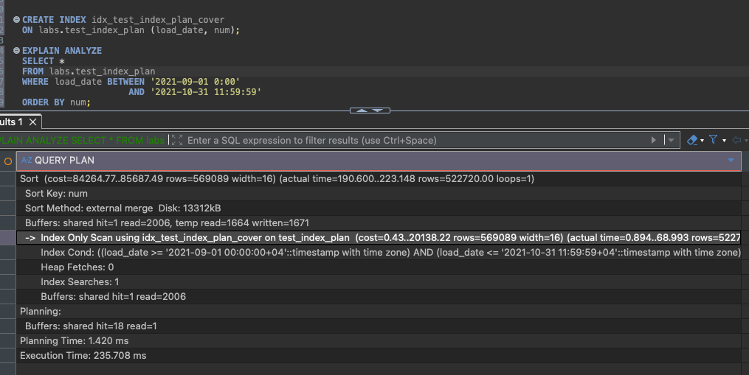
With the B-Tree index removed and BRIN created, the plan changed to Bitmap Index Scan + Bitmap Heap Scan.
Notable lines:
Heap Blocks: lossy=2944 – Brin narrowed down to 2944 Brin blocks. Among those blocks re-check showed excess rows.
Rows Removed by Index Recheck: 21920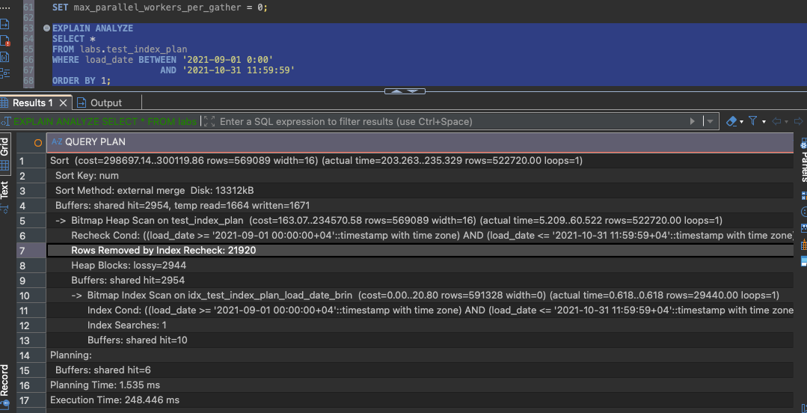

Task 2.1
INSERT INTO can be done together on all 14 rows instead of separately. Index structure can be applied to tables before loading the data in.
Task 2.2
Table copied from database to csv.
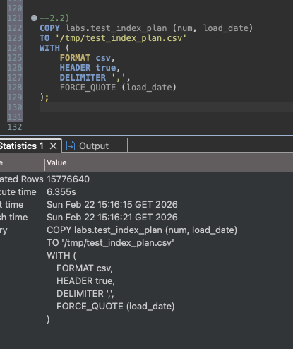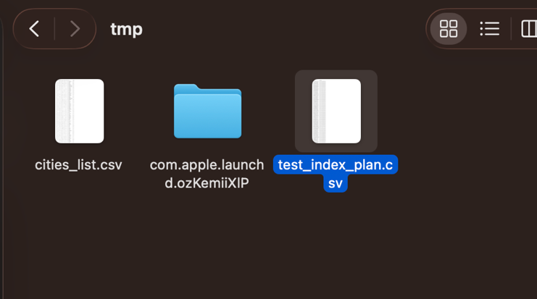
Same with filtered table.
Worked the other way around too -copied into new table from csv.
Task 2.3
Upsert is an insert that resolves conflicts. In this case, if row exists, its updated, if not its inserted.
